**Physics ATAR 12 /156**

**Semester One 2018**

**Question/Answer Booklet**

Student name: _______________________________________

#### Time allowed for this paper

Reading time before commencing work: ten minutes

Working time for paper: two and a half hours

**Materials required/recommended for this paper**

***To be provided by the supervisor***

This Question/Answer Booklet

Formulae and Constants Sheet

***To be provided by the candidate***

Standard items: pens, pencils, eraser, correction fluid, ruler, highlighters

Special items: non-programmable calculators satisfying the conditions set by the Curriculum Council for this course

**Important note to candidates**

No other items may be taken into the examination room. It is your responsibility to ensure that you do not have any unauthorised notes or other items of a non-personal nature in the examination room. If you have any unauthorised material with you, hand it to the supervisor before reading any further.

Student Marks

|  |  |  |  |
| --- | --- | --- | --- |
| **Section** | Percentage of paper | Maximum mark | Student mark |
| Section One:  Short response | 34% | 54 |  |
| Section Two:  Problem-solving | 56% | 86 |  |
| Section Three:  Comprehension | 10% | 16 |  |
| Student Mark | | | /156 | % |

**Structure of this paper**

|  |  |  |  |  |  |
| --- | --- | --- | --- | --- | --- |
| Section | Number of questions available | Number of questions to be answered | Suggested working time  (minutes) | Marks available | Percentage of exam |
| Section One:  Short response | 12 | 12 | 50 | 54 | 34 |
| Section Two:  Problem-solving | 5 | 5 | 90 | 88 | 56 |
| Section Three:  Comprehension | 1 | 1 | 10 | 16 | 10 |
|  |  |  |  | 158 | 100 |

**Instructions to candidates**

1. The rules for the conduct of Western Australian external examinations are detailed in the *Year 12 Information Handbook 2015.* Sitting this examination implies that you agree to abide by these rules.

2. Write answers in this Question/Answer Booklet.

3. You must be careful to confine your responses to the specific questions asked and to follow any instructions that are specific to a particular question.

1. Working or reasoning should be clearly shown when calculating or estimating answers. Answers should be given to the appropriate number of significant figures. Answers not given to the appropriate number of significant figures may result in marks being deducted, up to a maximum of 4 marks.

5. Spare pages are included at the end of this booklet. They can be used for planning your responses and/or as additional space if required to continue an answer.

* + Planning: If you use the spare pages for planning, indicate this clearly at the top of the page.
  + Continuing an answer: If you need to use the space to continue an answer, indicate in the original answer space that the answer is continued at the “Back of Booklet”. Clearly label the number of the question(s) that you are continuing at the back of the booklet.

**SECTION ONE: Short Answer, x questions worth y marks**

**QUESTION ONE (6 marks)**

The diagram on the left shows a book, M, of mass 1.20kg, suspended from point A by a vertical string. A wire cord joins a 10.0kg box sitting on a rough desk to a hook on a classroom wall, where it makes an angle of 30.00 to the wall.

a) Determine the magnitude of the tensile force along in the string.

(1 mark)

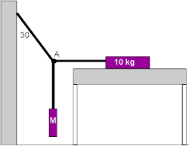

b) Determine the magnitude of the tension in the wire cord. (3 marks)

c) Determine the frictional force between the book and the desk. (2 marks)

**QUESTION TWO (6 marks)**

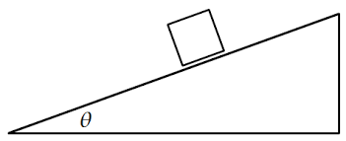

The diagram on the left shows a box of mass 10.0kg sliding down a **frictionless** ramp which makes an angle, q, of 28.00 to the horizontal.

1. Turn the diagram above into a free body diagram, showing all the real forces acting on the box. (2 marks)
2. Determine the acceleration of the box down the ramp. (2 marks)
3. A pulley is installed at the top of the ramp, as shown in the diagram below. Determine the mass of a hanging box, m2, which will put the system into equilibrium. (2 marks)

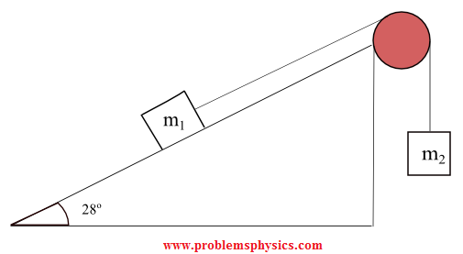

**QUESTION THREE (4 marks)**

A golfer is attempting to land a ball from the tee onto the green using a nine iron, which launches the ball at an angle of 41.00 to the horizontal. He can launch the ball at a speed of 148km/h. The green is circular with a radius of 12.0m, the centre of the green is 135m from the tee and the ground between the tee and the green is completely horizontal.

**Show** whether or not the ball lands on the green.

**QUESTION FOUR (4 marks)**

Table 1: Earth’s Physical Data

|  |  |
| --- | --- |
| **Quantity** | **Value** |
| Surface gravitational field instensity | 9.80 m/s/s |
| Planetary radius | 6370 km |
| Orbital radius | 1.50 x 108 km |
| Planetary mass | 5.97 x 1024kg |
| Day length | 24 hours |
| Year length | 365.25 days |

Use the data in the table on the right and one of the relevant equations on the data sheet to show that the mass of the sun is in the order of 1.99 x 1030 kg.

QUESTION FIVE ( marks)